

**ETHEREUM BEHAVIORAL DESIGN PATTERNS –**

**COMMIT –REVEAL**

Date: 12/04/2018

Brent Anthony Tudas

Sandra Alleine Blanca

Jaymar Dingcong

Robert Aries Dela Paz

Kimberly Mae Reyes

Patrick Oliver Palmero

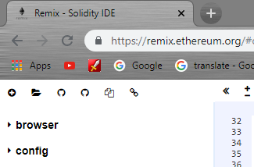**INSTRUCTIONS**

Go to <https://remix.ethereum.org/>

1. Click the icon and go to the folder

Directory of this document and select

CommitRevealElection.sol

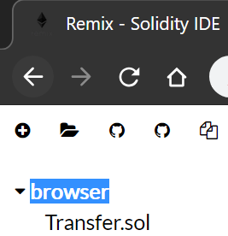

1. Click “browser” and it will collapse  
   find “CommitRevealElection.sol” and select it.



1. 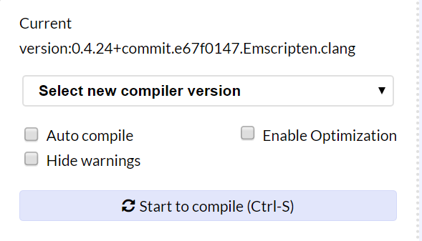Select new compiler version. Set it to 0.4.24+commit version.

Then, select Run tab.

1. Select ***Environment*** change itto JavaScript VM.
2. Select **Account** from the drop down button. Remember you chosen account.
3. 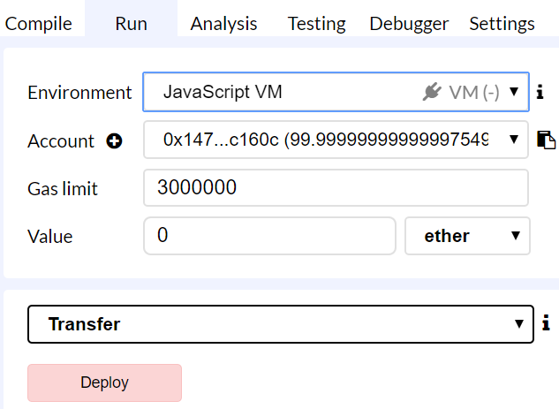 Click **deploy**.

**Deploying the Contract**

For the first parameter put the duration of the election then second input goes to the first candidate for the election and third input goes for the second candidtate.

Ex. 120, “brent”, “Anthony”

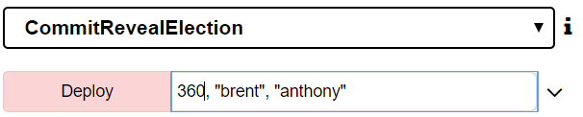

**Commiting a Vote**

Find the commitVote field and provide the index of the candidate and a “-“ symbol then the password for cracking your secret vote. Then click the button.

Ex. “1-mypassword”



**Revealing a Vote**

Find the revealVote field and put the value of the vote then hit the button.

Note: You have to wait the end of the duration of the election before revealing votes. In this examples case it is 120 seconds.

Ex. “1-mypassword”



**Getting candidate number of Votes**

After revealing the vote it will now be counted in the total of the candidate votes. 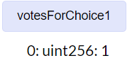

**Getting Winner**

Make sure that before calling this function the election has ended and all commited votes are revealed.

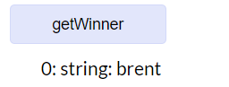



**References:**

**Commit-Reveal Documentation -**

[**https://karl.tech/learning-solidity-part-2-voting/**](https://karl.tech/learning-solidity-part-2-voting/)